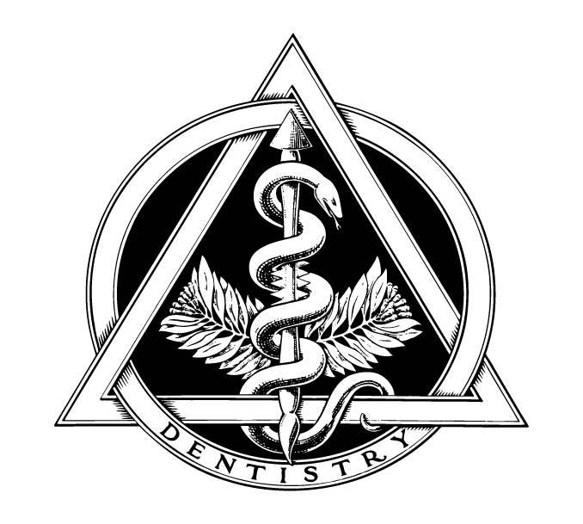
Robert R. Shaw, D.M.D.
Family Dentistry

Communication Preference/ Consent

Check which of the following we may use for communication:

- Phone Call
- Text Message
- Email

Please update your current information:
Patient Name:
Home Phone Number:
Cell Phone Number:
Email:
Current Mailing Address:

- By checking this box, I consent to the following: Dr Robert Shaw's office or its service provider may contact me to provide health care information such as health care information such as appointment reminders and information about treatment, payment, my account or insurance, using artificial or prerecorded voice or telephone equipment that may be capable of automatic dialing.

Signature: Date:

